The Oorts constants are local tracers of the Milky Way Kinematics

* The Milky Way (MW) rotates differently, and it has an overall flat rotation curve.
* Measuring the rotation curve of the Milky Way to high precision is difficult due to our location in the MW and observational constraints.
* The Oort constants described both motions of stars near out Sun and the slope MW rotation curve at the Sun's distance from the MW center.
* Assuming circular orbits and axisymmetric potential, expanding the velocity field in the solar vicinity shows proper motion in galactic longitude and latitude direction, as well as the line of sight velocity, have double sinusoidal dependence on the galactic longitude *l:*
* \(v_{los} = d(K+C cos 2l+A sin 2l)\\ \mu_l =(A cos 2l -Csin2l+B)cosb+\frac{1}{d}(u_0sinl-v_0cosl)\\ \mu_b = -(Asin2l+Ccos2l+K)sinb\hspace{0.1cm}cosb+\frac{1}{d}[(u_0cosl+v_0sinl)sinb-w_0cosb]\)where *A, B, C,*and *K* are the Oort constants, and they represent the transverse shearing, vorticity, radial streaming, and divergence of the local velocity field.
* We studied how to derive the Oort constants from Gaia data and how the observed data are different from a theoretical model.

## The main sequence stars from Gaia DR2 were divided into 5 color populations and analyzed

* Different stellar populations have disparate kinematics properties
* Main sequence stars are divided into five groups based on their color following the criteria outlined in (Li, 2019): \(G_{BP}-G_{RP}-E(BP-RP)\)<0.8, 0.8~1.2, 1.2~1.6, 1.6~2.4, >2.4
* Sampling limits: parallax > 2mas (d<500 pc). For μl and  vlos, |b|<20 deg; for μb, 40<|b|<50 deg.
* The distribution of proper motions and vlos in the galactic longitude and latitude directions are plotted after correcting the solar peculiar motion with respect to the LSR, (u0, v0, w0)
* We use their binned means to fit the models
* We used the Monte-Carlo-Markov-Chain method to estimate the uncertainties of the model parameters considering the results of Δμl and Δμb , along with their errors propagated from the observational results, at the same time, where the log-likelihood is defined as:\(-\frac{1}{2}\sum_i \Bigg(\frac{(\langle \Delta \mu_l \rangle_i -\bar y_{1i)}^2 }{\sigma_{\langle \Delta \mu_l \rangle_i}^2+error_{\langle \Delta \mu_l \rangle_i}^2}+ln [\sigma_{\langle \Delta \mu_l \rangle_i}^2+error_{\langle\Delta \mu_l \rangle_i}^2 ]\Bigg)-\frac{1}{2}\sum_j \Bigg(\frac{(\langle \Delta \mu_b \rangle_j -\bar y_{2j})^2 }{\sigma_{\langle \Delta \mu_b \rangle_j}^2+error_{\langle \Delta \mu_b \rangle_j}^2}+ln [\sigma_{\langle \Delta \mu_b \rangle_j}^2+error_{\langle \Delta \mu_b \rangle_j}^2 ]\Bigg)\)
* The reddest two stellar groups are the best tracers to derive the Oort constants. The bluer and younger stars show more deviation from the model.
* For the reddest group, we found the Oort constant are: A = 15.3 ∓ 1.5, B = -12.4 ∓ 1.2,, C = -1.7 ∓ 1.5 and D = -1.63 ∓ 1.5.

## The Results shows longitudinal and line of sight velocity have significant deviations from the theoretical model

**Δμl:**

* The samples have over dense regions near 270 and 290 degree and a smaller than expected peak around 180 degree.

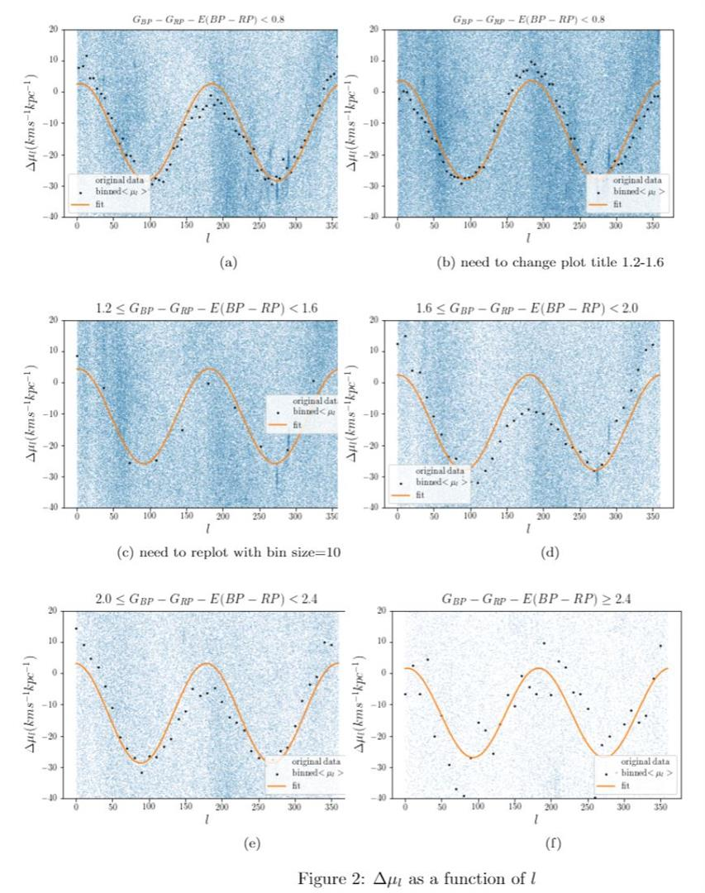

**Δμb:**

The first three stellar populations show good agreement to the double sine functions. The other groups have fewer samples and more disparity and randomness in the latitudinal proper motion  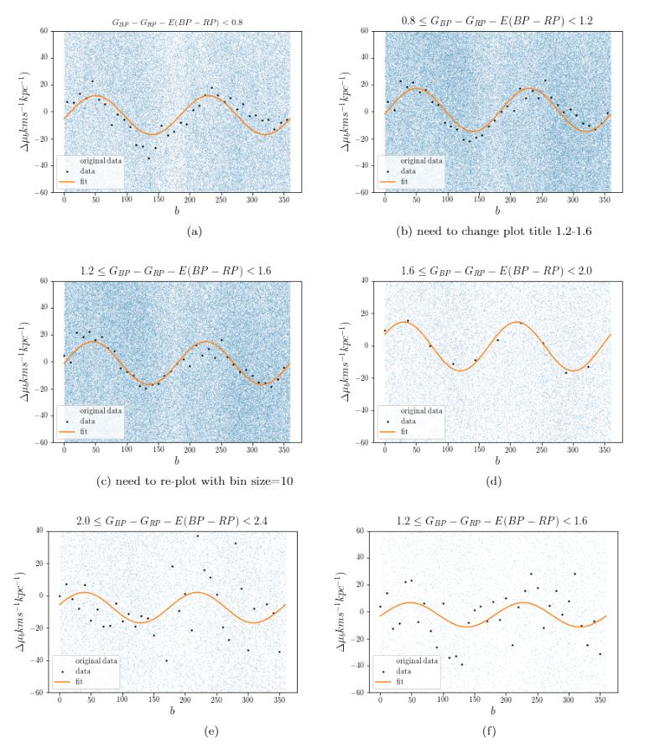**vlos:**

* Gaia DR2 only provides enough radial velcoity for the reddest two stellar groups.
* The vlos vs l function of the second group shows the sinusoidal function shifts downward from the second peak around 200 deg.

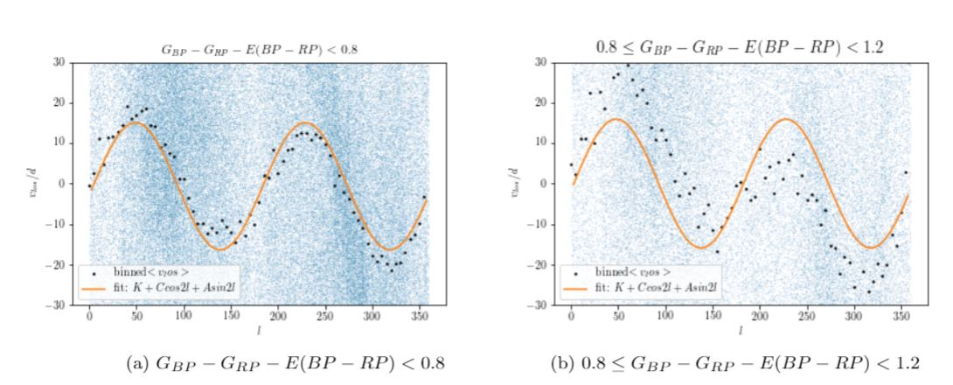

## A toy model simulation to investigate how proper motion and line of sight velocity behaves under an idealized scenario.

**Simulation Set-up:**

* To determine what sampling criteria, what range of galactic distance and latitude values give the most accurate derivation of the Oort constants
* Simulated the motions of X0,000 test particles under the MW potential and computed their proper motions and line of sight velocity after 10 Gyr when they are approximately in equilibrium.
* The model for MW potential we used is 2014MWPotential from *galpy.*
* Varied the sampling criteria of test particles to examine the trends of*vlos, μl*and*μb* over *l*

**Results**

1.The line of sight velocity and longitudinal proper motions of stars within 2kpc from the Sun and with |b|<20 deg are well described by the Oort constants double sinusoidal models. 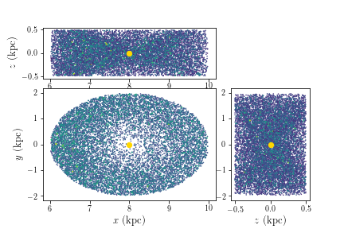

a) Spatial distribution of the test particles with <2kpc

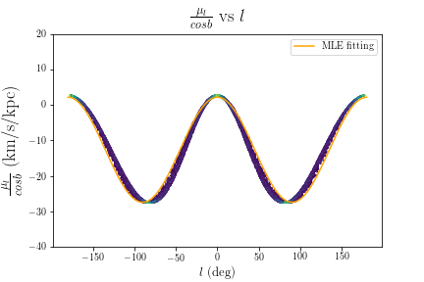

b) The function of *vlos* / d vs *l* for stars with d<2kpc and |b|<20 deg

The line of sight velocity shows larger dispersion.

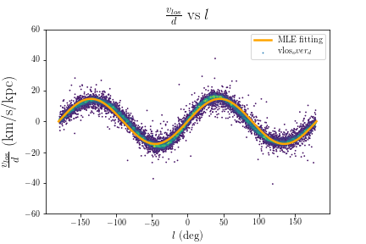

c) The function of *vlos* / d vs *l* for stars with d<2kpc and |b|<20 deg

2. The proper motion in the latitude direction follows the double sinusoidal model for stars with |b| < XX deg. μb shows larger dispersion.

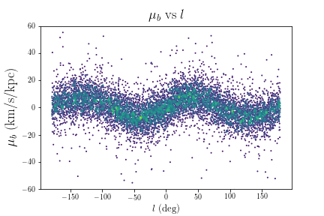

## The Gaia space telescope

* Gaia space telescope measures the parallax, proper motion, and radial velocity of stars with unprecedented accuracy and multitude.
* We used over 6 million Main Sequence Star near the Sun from ***Gaia DR2***which holds the measurements of over 1.6 billion stars.
* We look forward to using the newly released ***Gaia EDR3*** data to derive the Oort constants.

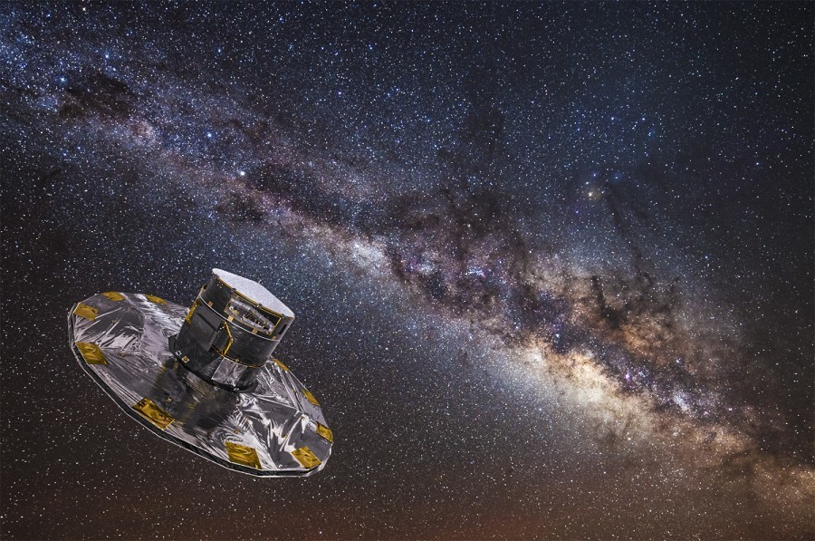An artist's concept of the Gaia spacecraft. Credit: ESA.

## Summary

* Gaia provides a large data catalog of proper motions and radial velocity to derive the Oort constants near the Sun.
* Different stellar populations show significant differences in their kinematics and how they follow/deviate from the Oort constants model.
* The function of longitudinal proper motions over the galactic longitude has a lower peak than the expected double sinusoidal function. This deviation is not due to the single sine contribution from the sun's peculiar motion
* Our toy model shows that for stars within 2kpc from the sun, their motions with respect to the sun follows the function described by the Oort constants.
* Even under the circular orbit and axisymmetiric potential, the line of sight velocity and proper motion in the latitudinal direction have larger dispersion than the longitudinal proper motion.